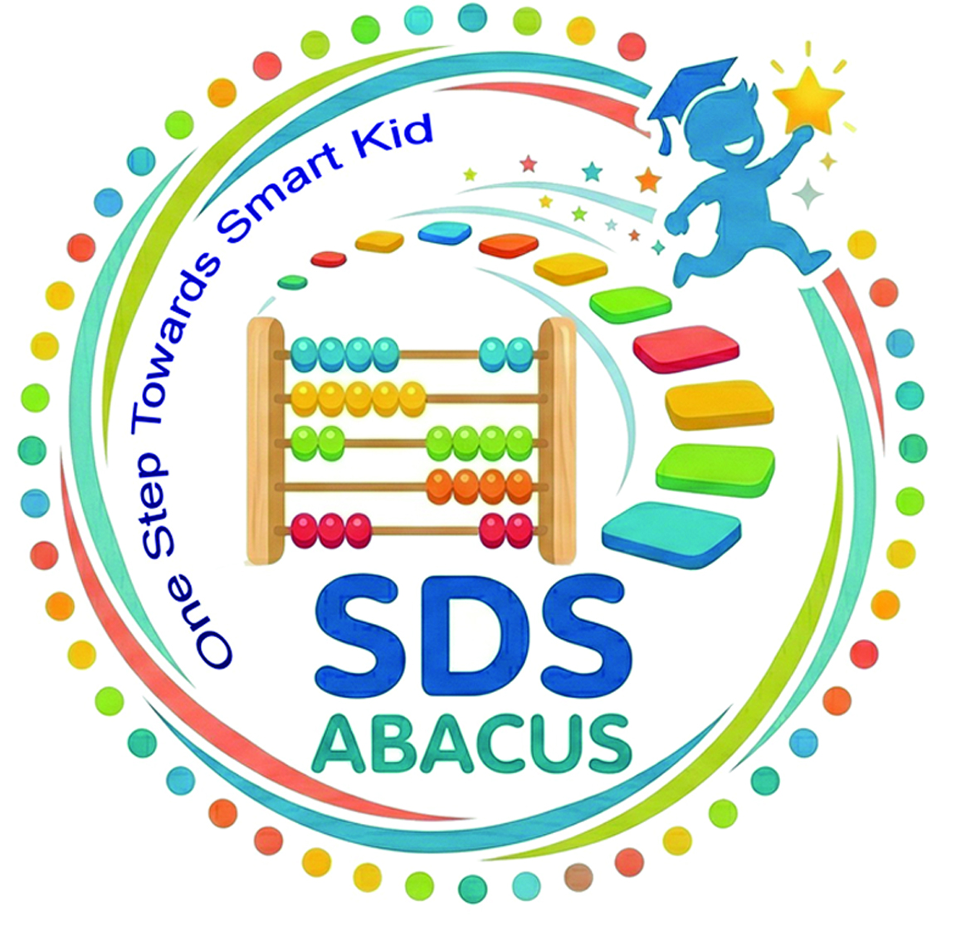

SDS ABACUS

A Unit of M/S Srishti Design Studio (SDS Education) | Estd. 2006 A.T. Road, Gaurisagar Tiniali, Sivasagar, Assam - 785664 📞 +91-99543-28379, |7002055801 ✉ sdseducation2006@gmail.com 🌐 sdseducation.in |sdsabacus.com
Govt. Regd. No. RF/SIVA/166/21

Franchise Proposal

Table of Contents
- Executive Summary
- About the Organization
- Vision and Mission
- Importance of Abacus Education
- Franchise Opportunity
- Business Model
- Courses Offered
- Franchise Benefits
- Infrastructure Requirements
- Investment Details
- Income Opportunity
- Marketing and Support
- Training and Certification
- Franchise Terms and Conditions
- Benefits of Partnering with Us
- Contact Information

1. Executive Summary
The Abacus Training Institute Franchise Program is an excellent opportunity for entrepreneurs, teachers, and coaching center owners to build a successful business in the education sector.
Our institute provides scientifically designed Abacus training that enhances children’s mental calculation ability, concentration, memory power, creativity, and self-confidence.
We invite interested individuals and organizations to join us as franchise partners.

2. About the Organization
SDS Abacus is an educational institution operating under M/S Srishti Design Studio. With years of experience, the organization has been providing quality education and skill development training in computer and technology education.
Courses offered by the institute:
- Abacus Training
- Mental Math Program
- Computer Education
- Skill Development Courses
- Personality Development Programs
Our goal is to provide affordable and quality education while creating entrepreneurial opportunities through our franchise system.

3. Vision and Mission

Vision
To develop children with advanced learning abilities and establish ourselves as a leading institution in Abacus and Mental Math education.

Mission
- Improve children’s mathematical abilities
- Enhance concentration and memory power
- Provide affordable and quality education
- Expand educational opportunities in urban and rural areas

4. Importance of Abacus Education
Abacus education is a globally recognized learning method that supports brain development in children.

Benefits of Abacus Education
- Faster calculation skills
- Improved concentration power
- Strong memory enhancement
- Increased self-confidence
- Development of visualization skills
- Coordination of left and right brain functions
- Better academic performance
Due to these benefits, the demand for Abacus education among parents is rapidly increasing.

5. Franchise Opportunity
We provide a complete franchise model for individuals and institutions interested in starting an Abacus Training Center.

Who Can Start an Abacus Center?
- Coaching Centers
- School Teachers
- Entrepreneurs
- Educational Institutions
- Tuition Centers
- Homemakers
- Any Training Institute

Franchise Models

1. Single Center Franchise
Operate an authorized Abacus training center in your area.

2. Area Franchise
Manage multiple centers within a district or region.

3. School Collaboration Program
Provide Abacus education through partnerships with schools.

6. Business Model
Our franchise model is simple, reliable, and profitable.

Sources of Income
- Student admission fees
- Monthly tuition fees
- Study material charges
- Certification fees
- Competitions and event programs
- Advanced level courses

Student Age Group
Children aged 5 to 15 years.

Teacher Training
Individuals aged 21 to 45 years with Higher Secondary qualification can undergo teacher training.

Types of Classes
- Weekly Classes
- Fortnightly Classes
- Online Classes
- Offline Classroom Training

7. Courses Offered

Foundation Level
Introduction to Abacus and number concepts.

Beginner Level
Basic calculations using the Abacus.

Intermediate Level
Fast calculation and visualization techniques.

Advanced Level
Mental Math without using the physical Abacus.

Grand Master Level
High-speed mental calculation and competitive training.

8. Franchise Benefits

Complete Academic Support
- Curriculum
- Teaching methods
- Student worksheets
- Practice materials
- Evaluation system

Brand Support
- Franchise Certificate
- Authorized Branding
- Promotional Materials
- Digital Marketing Support

Business Support
- Center setup guidance
- Teacher training
- Admission support
- Marketing strategies
- Student management assistance

Technical Support
- Online training support
- Digital learning materials
- Supporting software

9. Infrastructure Requirements

Minimum Requirements
- 200–500 sq. ft. classroom
- Whiteboard or Smart Board
- Tables and Chairs
- Proper lighting and ventilation
- Abacus teacher tools
- First aid kit
- Internet connection
- CCTV cameras (if required)

Staff Requirements
- 1 Center Coordinator
- 1–2 Trained Teachers

10. Investment Details
Item | Estimated Cost
Teacher Training Program | ₹10,000
Abacus Teacher Tool | ₹2,500
Books (8 Levels) | ₹1,600
Receipt Book | ₹300
Website & Software | ₹1,000 per level (renewable and to be collected from franchisee)
Classroom Setup | ₹30,000 – ₹80,000
Promotion & Miscellaneous | ₹10,000

Total Estimated Investment
₹75,000 – ₹2,00,000
The investment may vary depending on location and center size.

11. Income Opportunity

Example of Monthly Income
Students | Average Fee | Monthly Income
50 Students | ₹500 – ₹1000 | ₹25,000 – ₹50,000
100 Students | ₹500 – ₹1000 | ₹50,000 – ₹1,00,000
200 Students | ₹500 – ₹1000 | ₹1,00,000 – ₹2,00,000
With low operational costs and recurring admissions, Abacus education can become a highly profitable business.

12. Marketing and Support
We provide strong marketing support to our franchise partners.

Marketing Support
- Social media promotions
- Admission campaign support
- Poster and banner designs
- Digital advertisements

Operational Support
- Teacher guidance (Teacher Training Program)
- Business consultation
- Online meeting support
- Regular academic updates
- Software support for branch management

13. Training and Certification
All franchise partners and teachers will receive:
- Professional teacher training
- Guidance on teaching methods
- Student management strategies
- Certification upon successful completion

14. Franchise Terms and Conditions
- Franchise validity as per agreement
- Unauthorized use of brand name is prohibited
- Academic standards must be maintained
- Regular reporting and communication are mandatory
- Fees and royalty applicable as per agreement

15. Benefits of Partnering with Us

Special Advantages
- Growing education industry
- Low investment business opportunity
- High demand among parents
- Complete training and support
- Flexible operational system
- Long-term growth opportunities
- Trusted educational brand
By partnering with us, you can become a part of an important mission dedicated to children’s educational development.

16. Contact Information
M/S Srishti Design Studio (SDS Education)
📞 Contact Numbers:
9954328379, 7002055801
📧 Email:
sdseducation2006@gmail.com
📍 Address:
M/S Srishti Design Studio (SDS)
A.T. Road, GaurisagarTiniali,
Sivasagar, Assam
www.sdsabacus.com

Thank You
Welcome to this journey of building a brighter future through Abacus education.

